Email Drafting & Task Extraction Agent — LLD (Tech-Agnostic)
Objective
Transform unstructured emails into drafted replies, proposed meetings, and structured tasks, with verification guardrails and human-in-the-loop approval. Two-stage rollout:
- Stage 1 (Single Agent): Email → detect meeting intent → check calendar → propose slots → draft reply.
- Stage 2 (Multi-Agent): Adds task extraction + to-do creation + supervisor verification; consolidated reply.

1) Software Requirements Specification (SRS)
1.1 Purpose
Provide an automation service that reads emails, identifies meeting and task intents, checks calendar availability, creates tasks, and drafts professional replies for user review.
1.2 Scope
- Input: Email messages (subject, body, participants), past thread context.
- Output: Reply drafts, meeting slot proposals, task records.
- Integrations: Email Inbox API, Calendar API, Task Manager API, LLM (drafting/extraction).
- Modes: Stage 1 (scheduling only), Stage 2 (scheduling + tasks + supervision).
1.3 Assumptions & Constraints
- Runs as stateless API or background worker; uses short-term session memory.
- No auto-send; user must approve replies or meeting creation.
- Integrations can be mocked in lower environments.

2) Functional Requirements
2.1 Stage 1 (Single Agent – Scheduling)
- Read Email: Fetch latest email + thread summary.
- Intent Detection: Determine if the email requests a meeting.
- Entity Extraction: Dates/times, duration, attendees, time zones.
- Calendar Lookup: Free/busy and suggested meeting slots.
- Draft Reply: Propose 2–3 slots; include agenda; keep tone consistent.
2.2 Stage 2 (Multi-Agent – Scheduling + Tasks)
- Task Extraction: Identify tasks (title, owner, due date, priority).
- Task CRUD: Create/update tasks in a local store or external system.
- Supervisor Verification: Validate extracted tasks and slot feasibility.
- Consolidated Draft: Reply includes meeting options and task summary/confirmations.
- Clarifications: Ask for missing/ambiguous info (e.g., date, owner, location, TZ).
2.3 Notifications (Optional)
- Notify user on draft ready, task created, conflict detected, clarifications required.

3) Non-Functional Requirements
- Latency: P95 ≤ 3s with mocked services; real APIs may vary.
- Reliability: Retries with exponential backoff; idempotent writes.
- Security: OAuth/keys for live APIs; PII masking in logs; allow-listed tool actions.
- Observability: Tool call metrics, error rate, tokens (if LLM), P50/P95.
- Scalability: Horizontal scale of stateless workers; shared state via cache/DB.

4) System Context Diagram (Mermaid)
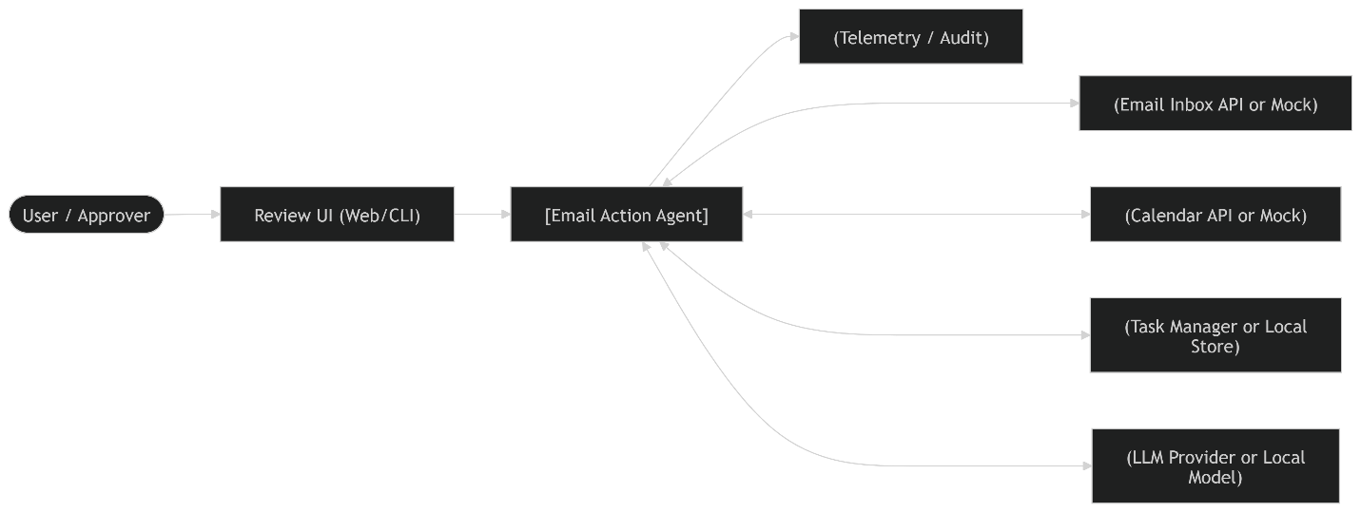

5) High-Level Component View (Modules)
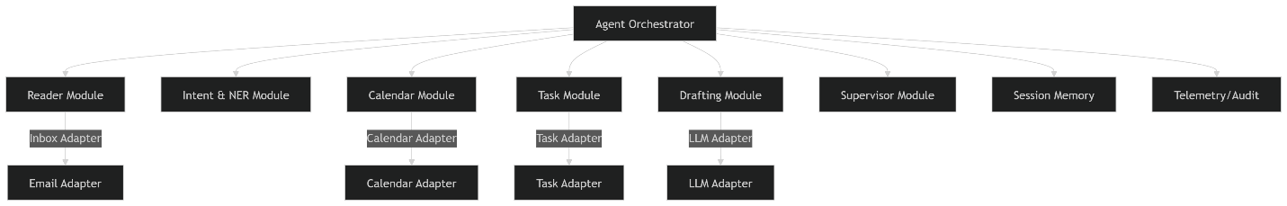
- Orchestrator: Flow control, policy guardrails, tool routing.
- Reader: Fetch + normalize email + thread context.
- Intent & NER: Meeting vs task; extract entities (attendees, times, due dates).
- Calendar: Free/busy lookup, slot scoring, conflict detection.
- Task: Creation/update, dedupe by sourceEmailId.
- Drafting: Reply composition, tone adherence.
- Supervisor: Validates outputs; requests clarifications when needed.
- Adapters: Pluggable connectors for Inbox/Calendar/Tasks/LLM.

6) Detailed Workflows
6.1 Stage 1 Flow (Scheduling Only)
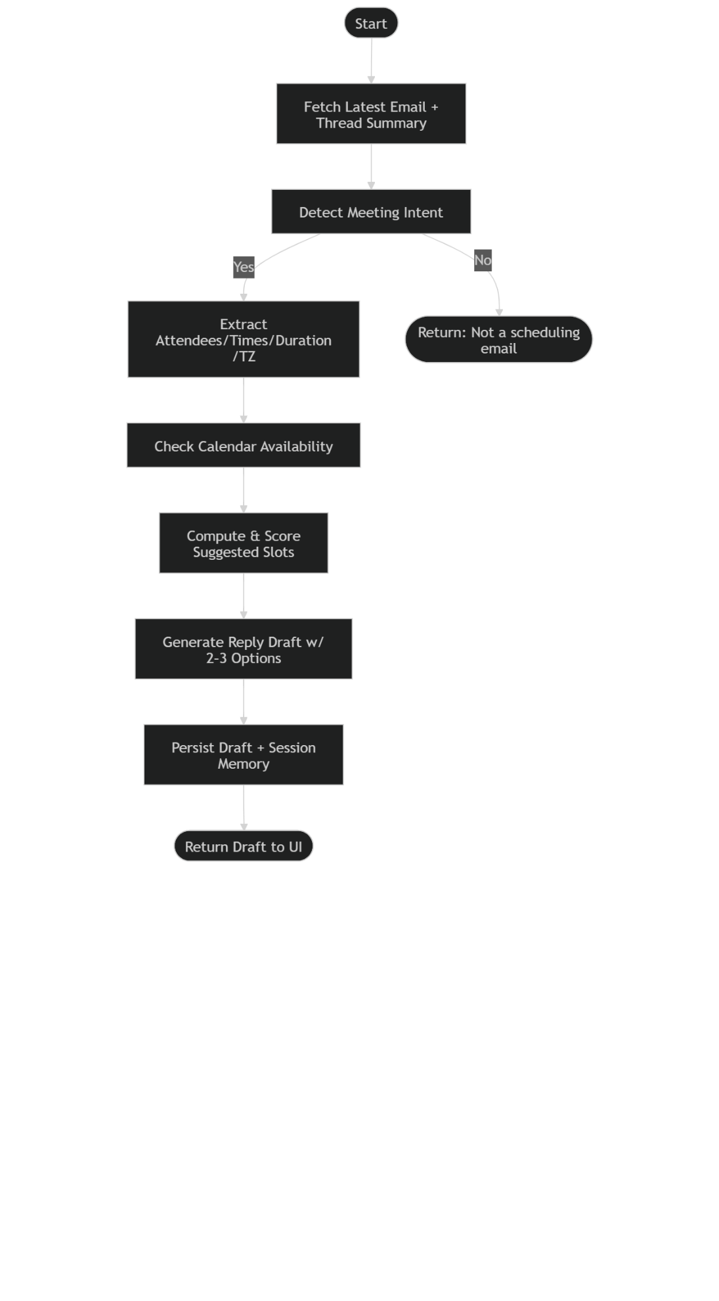
6.2 Stage 2 Flow (Scheduling + Tasks + Supervision)
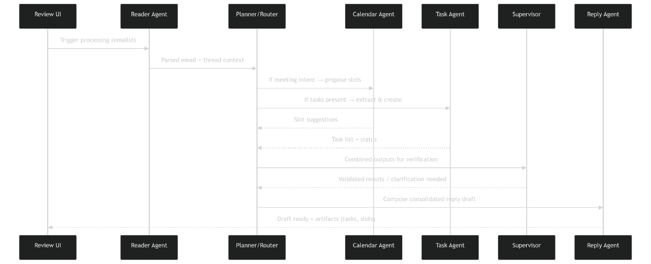

7) Data Model
7.1 ER Diagram (Mermaid)

7.2 Class/Type Diagram (Mermaid)
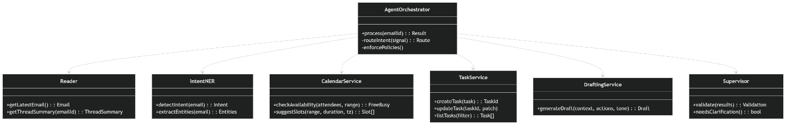

8) Tool / Adapter Contracts (Language-Neutral)
Use HTTP/REST, gRPC, or in-process interfaces. Schemas shown as JSON.
8.1 Email Inbox
// GET /inbox/latest
{
"id": "E-8712",
"threadId": "T-901",
"subject": "Sync this week?",
"from": "partner@example.com",
"to": ["me@org.com"],
"cc": [],
"body": "Can we meet Thu 2-4pm IST? Also please share draft by Friday.",
"receivedAt": "2026-02-11T08:30:00Z"
}
8.2 Calendar
// POST /calendar/availability
{
"attendees": ["me@org.com", "partner@example.com"],
"timeWindow": {"start":"2026-02-12T03:30:00Z","end":"2026-02-12T12:30:00Z"},
"timeZone": "Asia/Kolkata",
"durationMinutes": 30
}
// Response (suggested slots)
{
"suggestions": [
{"start":"2026-02-12T05:00:00Z","end":"2026-02-12T05:30:00Z","score":0.92},
{"start":"2026-02-12T07:30:00Z","end":"2026-02-12T08:00:00Z","score":0.88}
]
}
8.3 Tasks
// POST /tasks
{
"title":"Share draft deck",
"owner":"me@org.com",
"dueDate":"2026-02-13",
"priority":"High",
"sourceEmailId":"E-8712"
}
8.4 Drafting (LLM)
// POST /drafts
{
"context": {
"threadSummary": "Partner requests meeting + deck by Friday.",
"attendees": ["me@org.com","partner@example.com"],
"suggestedSlots": [
{"start":"2026-02-12T05:00:00Z","end":"2026-02-12T05:30:00Z"},
{"start":"2026-02-12T07:30:00Z","end":"2026-02-12T08:00:00Z"}
],
"tasks":[{"title":"Share draft deck","dueDate":"2026-02-13","owner":"me@org.com"}]
},
"tone":"professional"
}

9) State Machine — Email Processing
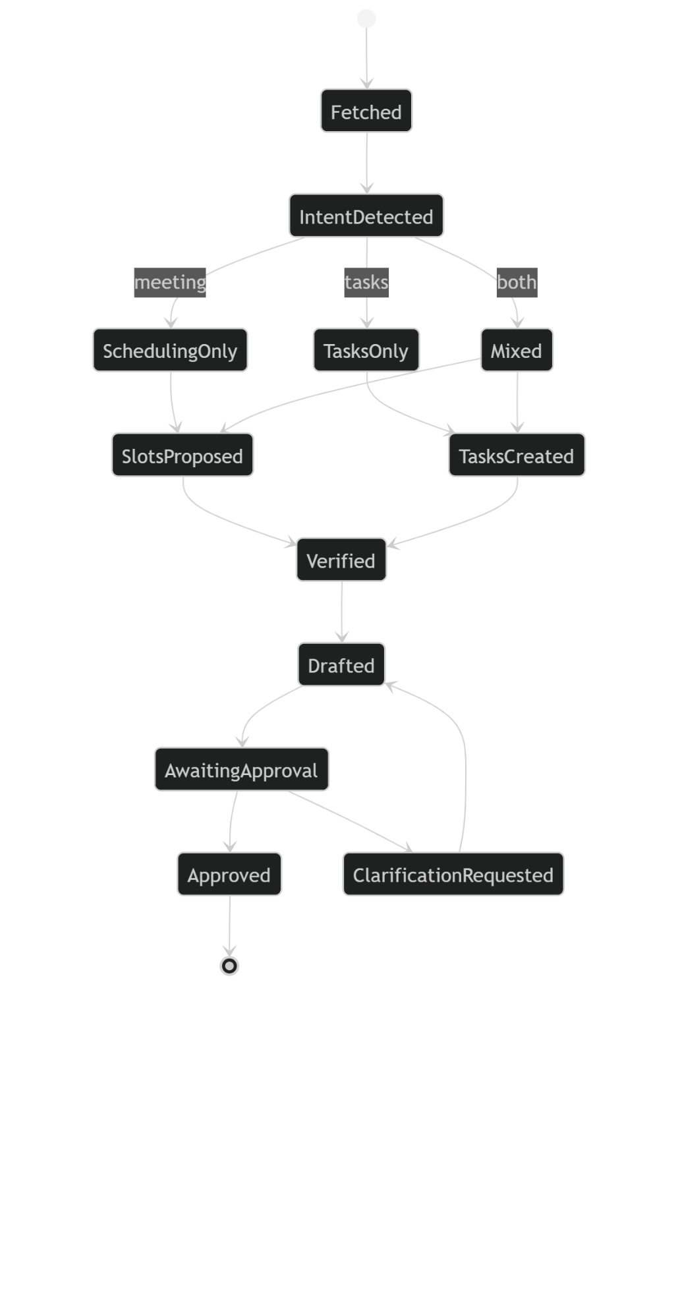

10) Error Handling & Idempotency
- Retries: Inbox/Calendar/Tasks adapters retry on transient 5xx with jittered backoff (max 3).
- Circuit Breaker: Opens after consecutive failures; returns degraded experience (e.g., “Unable to fetch availability, here are two generic slots”).
- Idempotency Keys: Use sourceEmailId + normalized title for tasks; dedupe meeting proposals by (threadId, attendees, duration, day).
- Partial Logging: Persist partial outputs (extraction.json, slots.json, tasks.json) to aid recovery.

11) Security & Guardrails
- Draft-Only Mode: No automatic send or calendar writes by default.
- Allow-Listed Actions: Restrict tool methods (read inbox, check availability, create placeholder tasks only).
- Prompt-Injection Defense: Ignore instructions within email that attempt policy overrides or data exfiltration; Supervisor enforces.
- PII Handling: Redact sensitive values in logs; store tokens securely.

12) Observability (Telemetry)
- Metrics: tool_calls, success_rate, latency_ms (P50/P95), retries, token_usage (if LLM).
- Logs: structured events for each tool call with redacted arguments.
- Traces: per-request spans across Reader → Calendar → Tasks → Drafting.

13) Deployment View
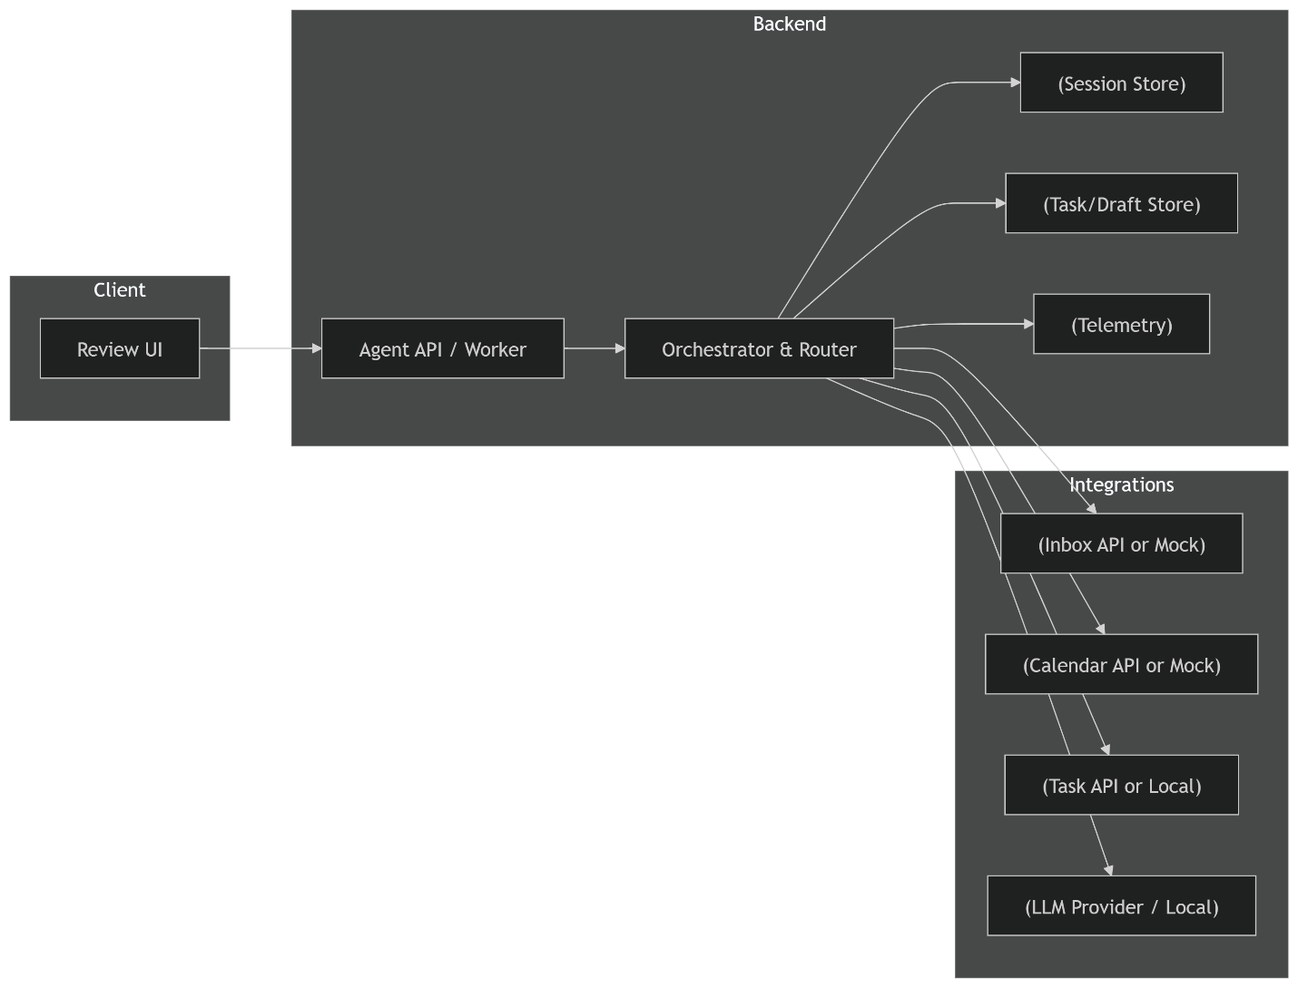

14) Configuration & Feature Flags
- enableTasks (Stage 2)
- draftOnly (true by default)
- slotCount (default 2–3)
- toneProfile (“professional”, “friendly”)
- llmProvider (“azure-openai”, “openai”, “local-llm”)
- timezoneDefault (organization default)

15) Testing & Evaluation
- Unit: NER parsing, time windows, dedupe rules, task schema validation.
- Integration: Inbox→Calendar→Draft; mixed-intent pipeline.
- Replay: Fixed email fixtures; assert deterministic drafts (seeded temperature).
- Security: Injection emails, PII redaction.
- Metrics: Task extraction precision/recall, routing accuracy, unsafe action rate.
- Acceptance (Stage 1): ≥2 valid slots; accurate context reference; human approval gate.
- Acceptance (Stage 2): precision ≥ 0.85, recall ≥ 0.80; verified consolidated draft.

